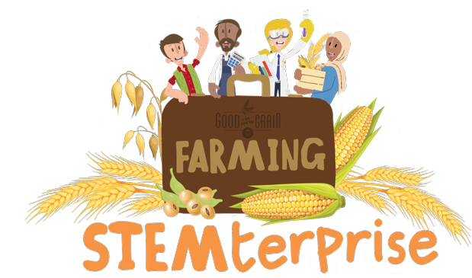
Taste Testing Scoring Template
Write the attributes you are testing along the top of the grid and then score each bar out of five for each feature.
Granola bar/ Feature | Taste | Texture | Shape | Smell | Things I liked about this bar | Things I did not like about this bar
A
B
C
D
E

© The National Farmers’ Union of England and Wales - All rights reserved. These resources may be reproduced for educational use only.

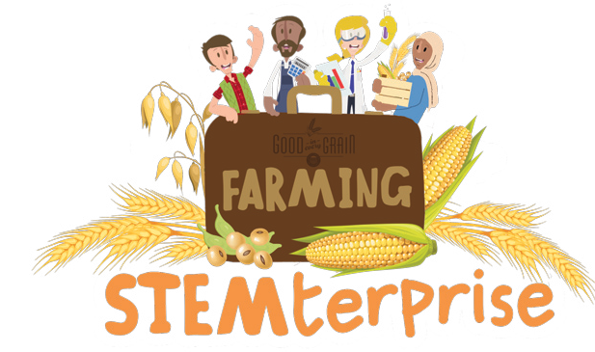
Market Research Tally Table Template

Question 1

Granola bar flavour | Tally

Question 2
What other factors are important to you when you are choosing a food product?
Factor |  |  | Tally
Price
Packaging
Locally Sourced Ingredients

© The National Farmers’ Union of England and Wales - All rights reserved. These resources may be reproduced for educational use only.

