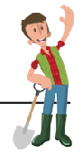

|  |  |
| --- | --- |
| **Cultivator/Tillage**  Function:  How Does it Work? | **Sprayer**  Function:  How Does it Work? |
| **Seed Drill**  Function:  How Does it Work? | **Combine Harvester**  Function:  How Does it Work? |

**Barley**

**Pet Food**

**Fish Food**

**Baby Food**

**Corn**

**Candy**

**Chalk**

**Toothpaste**

**Oats**

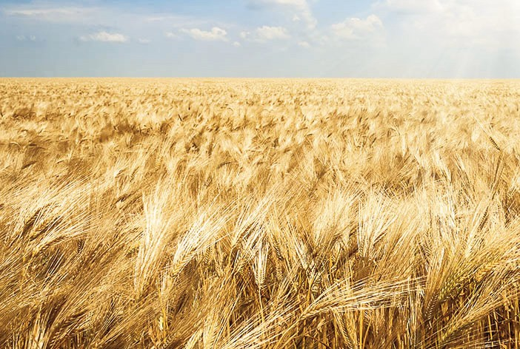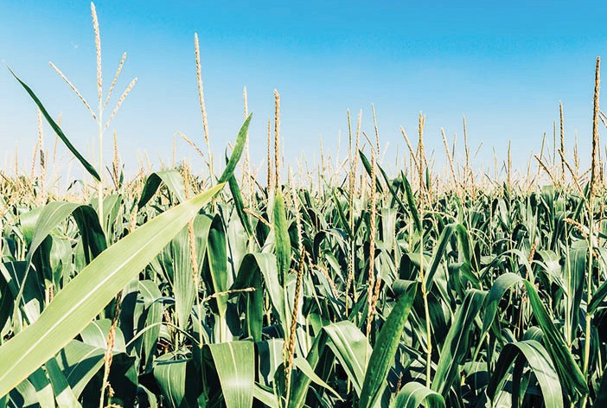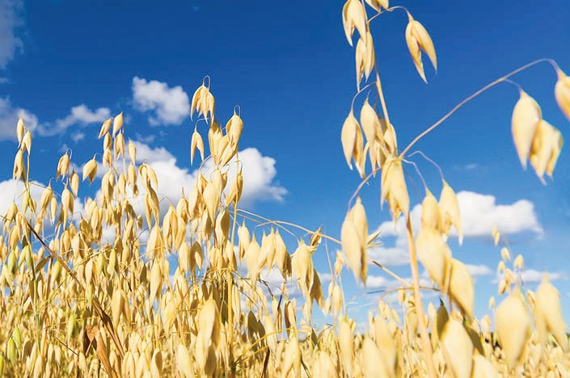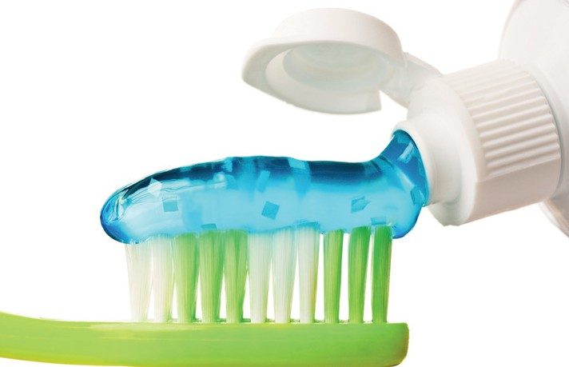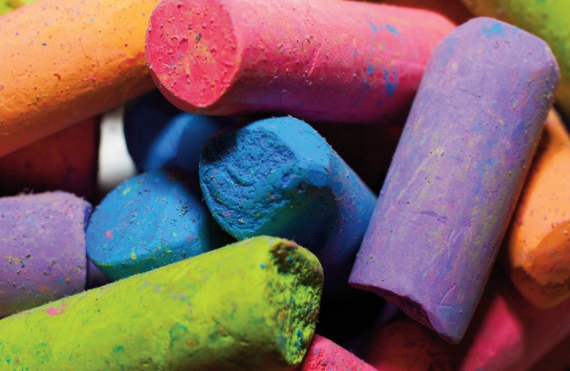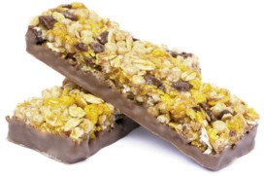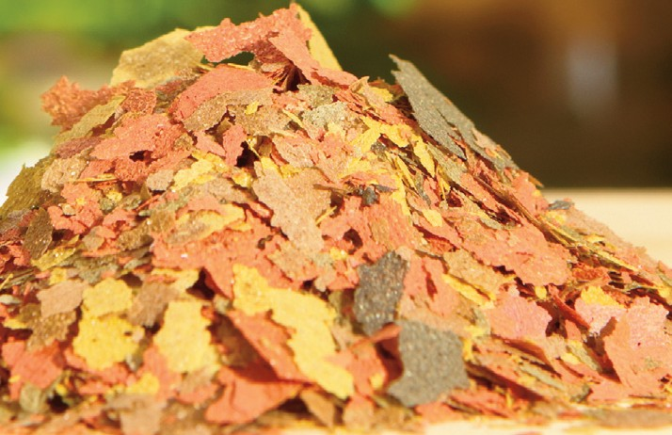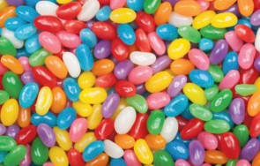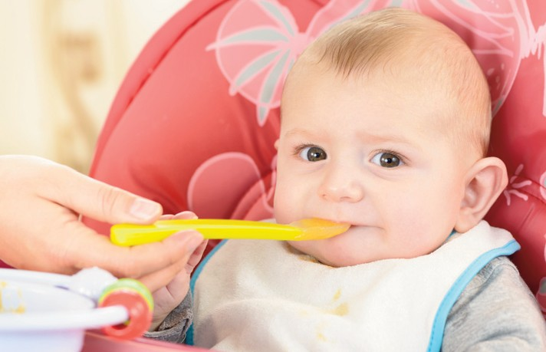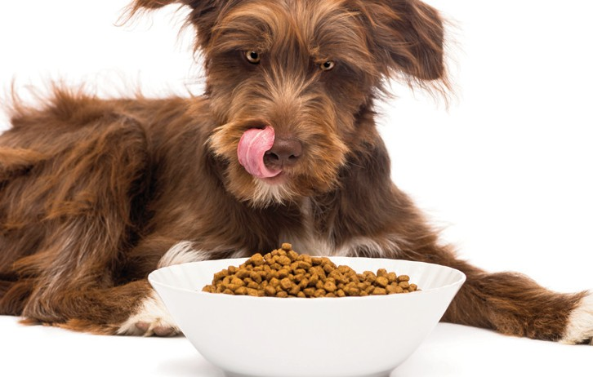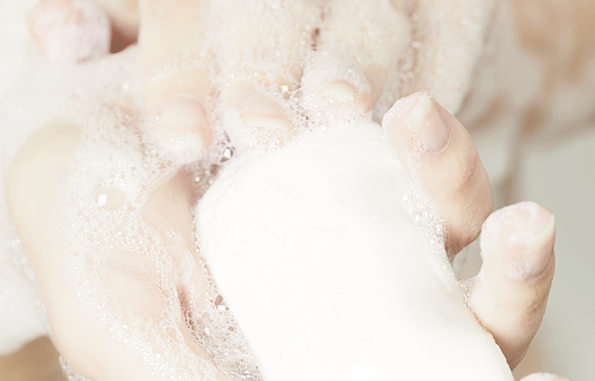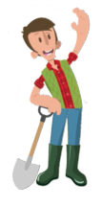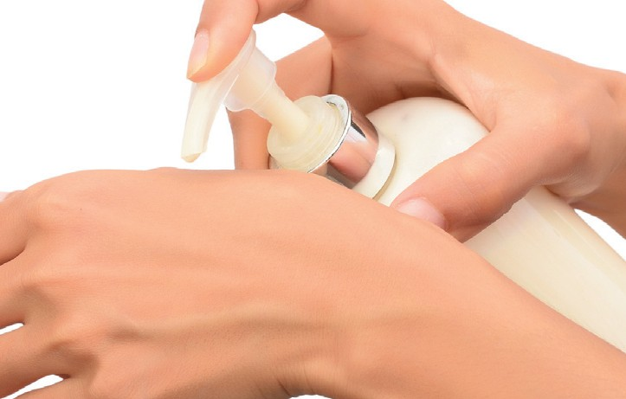

**Lotion**

**Granola**

**Soap**





|  |  |  |  |
| --- | --- | --- | --- |
| **Soybeans** | **Steering Wheel** | **Candle** | **Crayon** |
| **Wheat** | **Bread** | **Glue** | **Paper** |