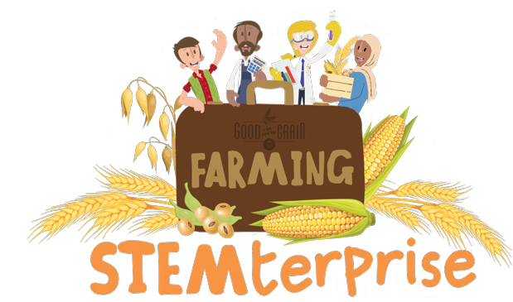
Types of Soil in Ontario
Soils are made of air, water, minerals, and organic matter. The amount of each of those elements determines soil types. There are several soil types in Ontario. Some are better for growing plants than others. The most common types of soil in Ontario’s agricultural areas are clay, loamy, and sandy. What kind of soil is in your area?

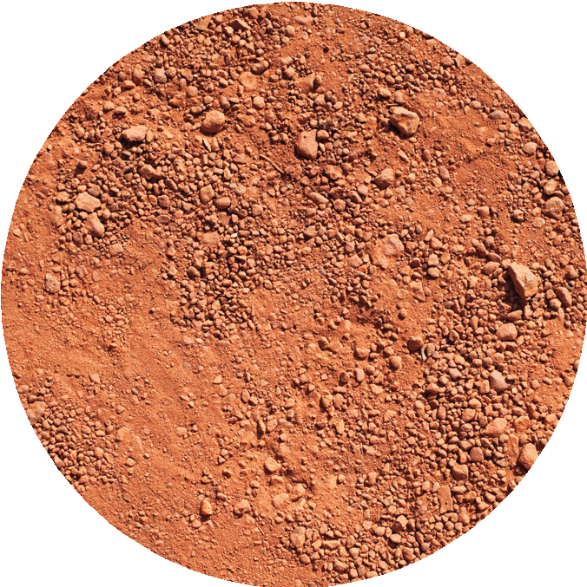
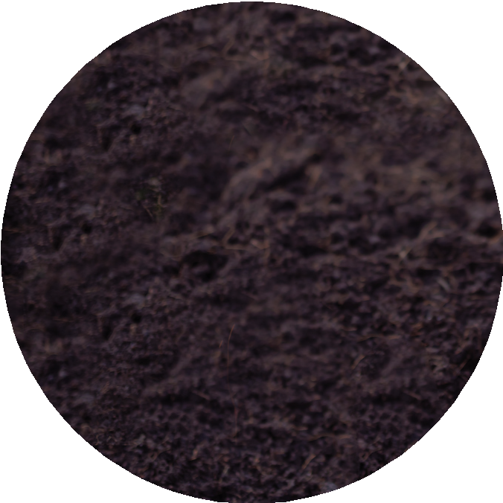
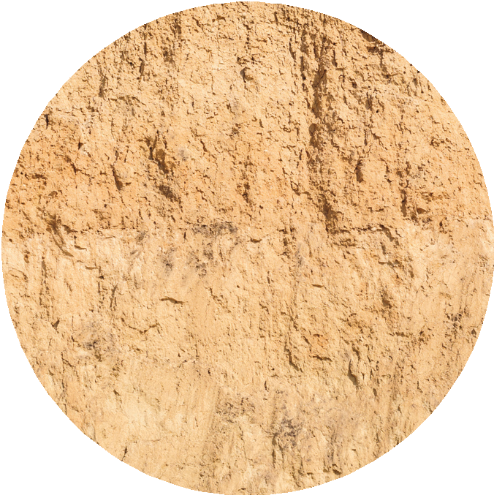
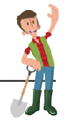
Clay
Clay is heavy! It stores water well but not air. It is smooth when wet but cracks when dry. It holds together if you squeeze it. Clay agricultural soil is not the same as the clay you make pots with.

Clay holds plant nutrients but drains slowly. It compacts easily so driving big machines on it when wet can damage it. Clay soil is improved by adding microbes.

Loam
Loamy soil is the best soil for growing! It is a mix of sand, clay, and silt. It holds water, does not dry out in summer, and stays together if you squeeze it.

Loam holds nutrients and drains well so it is good soil for many crops. It may have stones in it, depending how it was formed. That is not ideal. Loamy soil can be made stronger by adding microbes.

Sand
Sandy soil is mostly sand, which is tiny bits of rock! It is light and feels gritty. Sand is often low in nutrients. It has large particles, so it dries out quickly and nutrients and water can leach away. Plants growing in sandy soil may be dry and need watering and they may need organic fertilizer.

Sandy soil warms up quickly in the spring so it is great for early spring planting.

© The National Farmers’ Union of England and Wales - All rights reserved. These resources may be reproduced for educational use only.

Types of Soil in Ontario
Soils are made of air, water, minerals, and organic matter. The amount of each of those elements determines soil types. There are several soil types in Ontario. Some are better for growing plants than others. The most common types of soil in Ontario’s agricultural areas are clay, loamy, and sandy. What kind of soil is in your area?

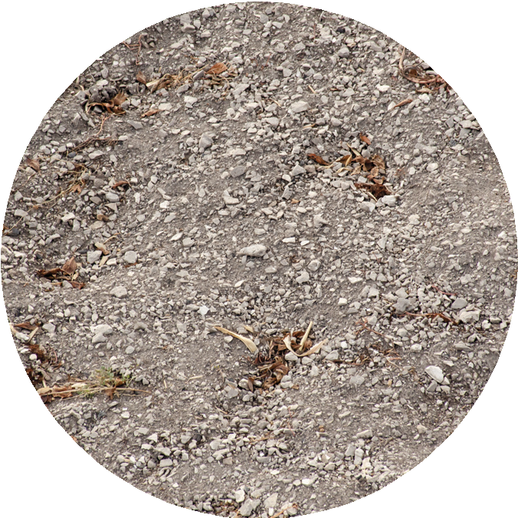
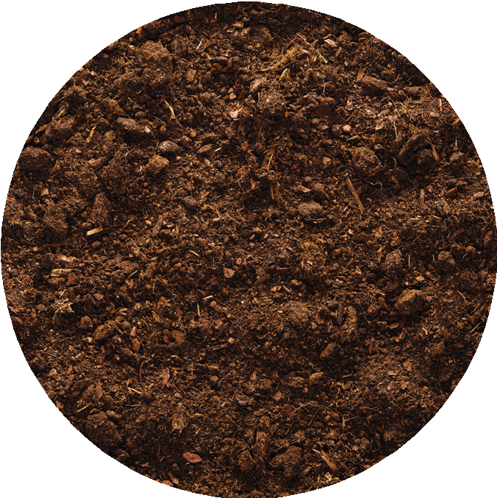
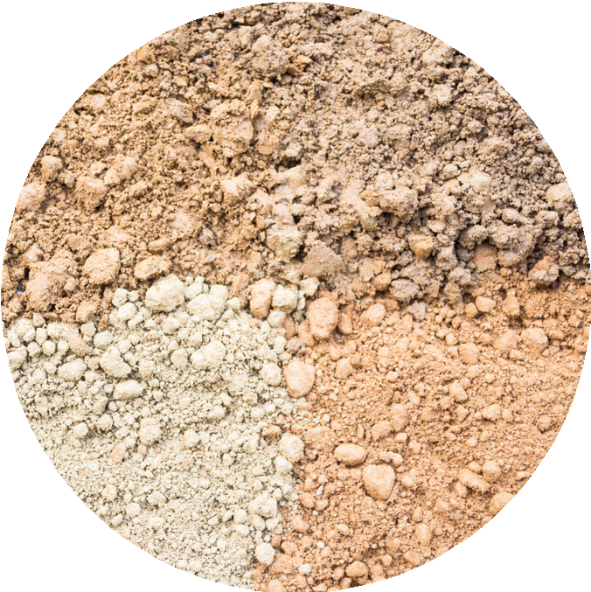
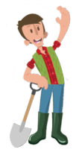
Chalk
Chalk soil has something in common with sidewalk chalk — both contain the mineral calcium carbonate!

Chalk soil does not hold water well, so it is difficult to farm. Chalk is susceptible to water erosion — heavy rain just runs off instead of soaking in. It also does not hold nutrients well.

To make chalky soil better, add organic material — compost, manure, or peat moss.

Peat
Peat soil is made from plant material decaying in a wet environment over thousands (!) of years. It holds moisture very well.

Peat soil is an excellent material for improving dry types of soil, like sandy soil. It helps make air spaces for roots and it does not contain harmful micro-organisms.

Peat is a non-renewable resource. It should be used carefully.

Silt
Silt is like sand but with smaller particles that are bigger than clay particles. When silt is dry, it feels like flour; when wet, it forms a ball.

Silty soil is more fertile than sand and easier to farm than clay. It does not filter water well; it compacts and gets hard so farmers avoid driving their heavy equipment on it when it is wet.

Compost and microbes improve silty soil.

© The National Farmers’ Union of England and Wales - All rights reserved. These resources may be reproduced for educational use only.

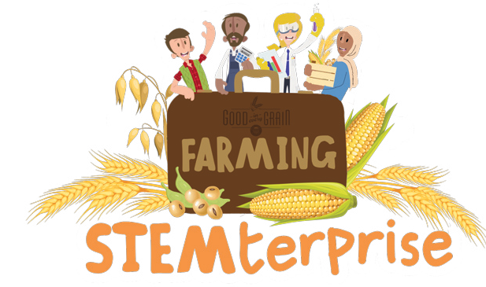
Investigation Planning

My research question:
Things I will keep the same:
One thing I will change:
What I will measure:
My prediction:

© The National Farmers’ Union of England and Wales - All rights reserved. These resources may be reproduced for educational use only.

