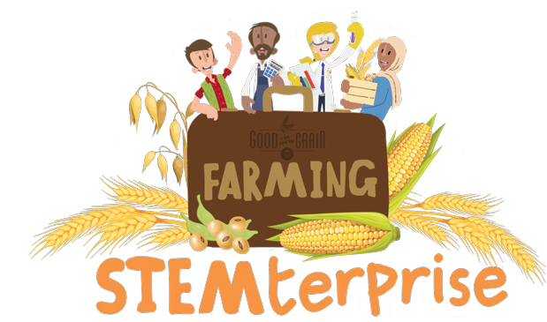
Seed Journal

Observation 1 | Observation 2 | Observation 3
Date: _____________________ Plant height: _______________ Description: | Date: _____________________ Plant height: _______________ Description: | Date: _____________________ Plant height: _______________ Description:
Observation 1 | Observation 2 | Observation 3
Date: ___________________ Plant height: _____________ Description: | Date: _____________________ Plant height: _______________ Description: | Date: _____________________ Plant height: _______________ Description:
© The National Farmers’ Union of England and Wales - All rights reserved. These resources may be reproduced for educational use only.

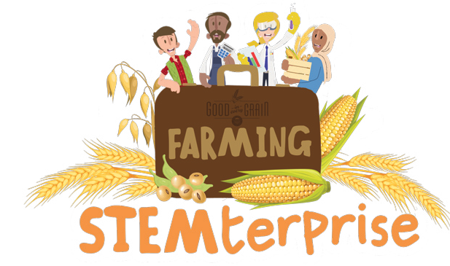
Investigation Planning

My research question:
Things I will keep the same:
One thing I will change:
What I will measure:
My prediction:

© The National Farmers’ Union of England and Wales - All rights reserved. These resources may be reproduced for educational use only.

