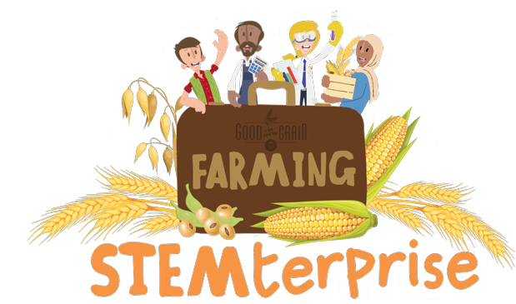
Granola Bar Marketing Strategy
Price you charge each customer per bar |  | Subtract
Cost of ingredients per bar
Profit = what’s left over

Profit Calculations | Business Name, Logo, and Slogan | Product Development Ideas
Market Research Findings |  | Design Sketch of Product
 | Packaging Design
Product Name Ideas |  | Promotion Ideas

Granola bar/ Variable
Taste
Texture
Shape
Size

A

B

C

D

E

