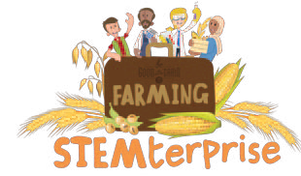
Flowering Plant Diagram

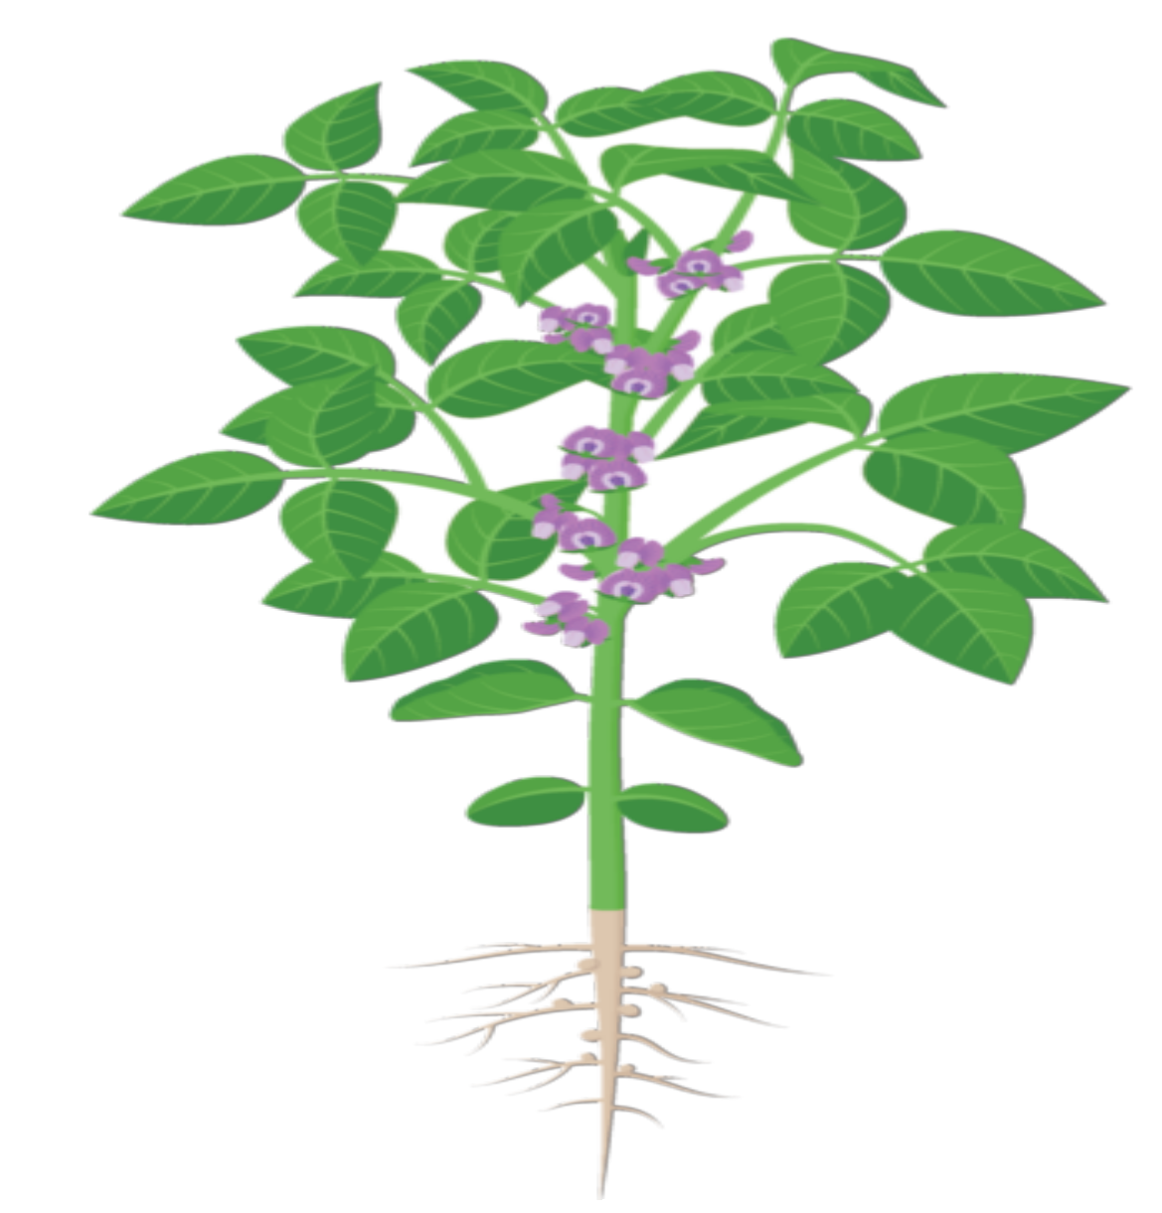
© The National Farmers’ Union of England and Wales - All rights reserved. These resources may be reproduced for educational use only.

My Research Notes - Parts of the Plant
Directions: Use this grid to keep track of your knowledge and new facts about parts of the plant.
Leaves  Function:  Uses: | Leaves  Function:  Uses: | Leaves  Function:  Uses:
Leaves  Function:  Uses: | Leaves  Function:  Uses: | Leaves  Function:  Uses:

© The National Farmers’ Union of England and Wales - All rights reserved. These resources may be reproduced for educational use only.

